

Strategy and work plan
Approved by Trustees July 2025

The Raft
c/o The Kings Centre
56 Bull Head Street
Wigston
Leicester
LE18 1PA

Email: info@theraftleicester.co.uk
www.theraftleicester.co.uk

Registered charity number: 1194852
Add your logo to the title page

Contents
About The Raft 3
1.1 Vision, mission, values 3
1.2 History 4
1.3 Where we are now 4
1.4 Legal status 5
1.5 Our aims 5

2. Our offer 6
2.1 Children and Youth 6
2.2 Adults 7
2.3 Training and Development 8
2.4 Exploration of emerging ideas, research and opportunities 9

3. Our market 10
3.1 Beneficiaries 10
3.2 Stakeholders 10
3.3 Donors and supporters 10

4. SWOT analysis 11

5. Our brand and messaging 11

6. Operational plan 12
6.1 Milestones and timescale 12
6.2 Partners 13
6.3 Funders 14
6.4 Premises and equipment 14
6.5 Policies 15

7. People, management and governance 15
7.1 Our team 15
7.2 Our board 16
7.3 Proposed management structure 16
About The Raft

Vision, mission, values
Our vision is for care-experienced children and families in Leicestershire to feel understood, valued and empowered to reach their full potential.

Our mission is to journey alongside Leicestershire’s care experienced children and families through providing trauma informed activities in three key areas: Children and Youth; Adults; and Training and Development with the aim of promoting recovery from early childhood trauma.

Value | What does this look like in The Raft
We are living it | We hear and understand the needs of care experienced children and those that support them. As a team who have lived experience in fostering and adoption, we get what it is like to care for children who have experienced trauma. We are willing to learn, adapt and shape our activities according to these needs and the feedback we receive from our beneficiaries.
We’re together | The Raft is a supportive community, aiming to navigate life alongside each other. We don’t always have the answers; our purpose is to share ideas, experiences, to hear each other’s stories and to be encouraging.
We’re safe | We promote belonging, understanding and compassion. It is important that safety and felt safety is foundational to all that we do. This includes ensuring we have rigorous safeguarding processes in place, and embedding trauma-informed awareness and practice across all our work.
We’re informed | We know and we work with relevant agencies, organisations and projects across Leicestershire to enable appropriate and safe signposting / referral.  We are aware of the landscape around care, fostering and adoption, and data, polices and reports that could influence our work. We will undertake regular training and continual professional development.
We’re fun | We are committed to creating and celebrating moments of enjoyment and laughter.

History
The history of The Raft starts in 2004 when Ruth Crook (founding trustee of The Raft) had a vision of a country house or place where families could receive care, training, support and preparation for life. A decade later, in 2014, Debbie Hill (foster carer and Home for Good Leicester) had a vision of providing a respite place for foster families.

In 2016, Sarah Gamble (who was working for Safe Families in Leicester) and Debbie Hill started to have conversations about caring for the vulnerable and the provision of trauma care by churches. This led to an initial meeting, on 22nd February 2018, with Michelle Nelson (Adoption UK / Adopter Voice Champion), Debbie Hill, Sarah Gamble, Esther Clark (All Nations Children’s Worker), Sharon Lesson (Adopter, employed Family Worker at St Johns church) and Ruth Crook (TLG, Teacher, Trainee Counsellor and Kintsugi). We all had a similar heart – to work with young people and families impacted by trauma and to encourage churches to respond. The leaflet we produced at this time speaks to this – we introduced the three charities we were initially supporting, praying for, advocating for and bringing together – TLG, Safe Families and Home for Good. At this time the verse 1 John 4:19 became very special “We love because he first loved us”.
In the early days we organised prayer meetings for all involved in these types of ministries. We welcomed Lisa Squires (Safe Families) in June 2019 and Julia Hamer (adopter) in Autumn 2019. We organised our first Raft conference in September 2019 – the speaker was Kat Osborn, CEO of Safe Families. We held prayer breakfasts, a trauma training evening with Home for Good at Hope Community Church and we met with our own church leaders.

During 2020 we decided to register The Raft as a charity, becoming registered on the 18th June 2021. Sharon, Ruth, Julia and Debbie were the founding trustees, with Paul Cromwell and Chris Plummer becoming trustees in summer 2023 and Carys joining the trustee team in January 2025. We now have a growing team of volunteers, still committed to that original vision of 20 years ago – a place in Leicestershire, The Raft Centre, for care-experienced children and their families.

Where we are now
As of Summer 2026, we have a volunteer team of 7 people which includes our four trustees. One of our trustees, Chris, is also our treasurer, and another trustee, Paul, is our safeguarding lead.

Our charity is experiencing steady growth and now delivers activities across three core strands: children, adults, and training and development. We are committed to offering specialist support for care-experienced children, addressing the impacts of trauma. We also provide targeted well-being and community support for caregivers, and we meet the ongoing training and development needs of all those engaged in this work.

Legal status
The Raft is a Charitable Incorporated Organisation (CIO), registered with the Charity Commission (charity number: 1194852), with a constitution and governed by a Board of Trustees.

We are a Christian charity, with a statement of faith.

Our aims
Our aims for the next 5 years are:
- Create and deliver activities under our 3 strands (adults, children and training) that help meet the unique needs of our beneficiaries (which could include expansion of our current offer as well as the identification of new opportunities).
- Expand our trustee board to 5 members and take steps to separate the trustee function from the operational side of the organisation.
- Create an operational team consisting of a CEO and administrator and project lead, and seek opportunities for funding these roles, initially on a part-time basis.
- Develop partnerships with churches across Leicestershire, encouraging regular financial giving and ongoing support through presentations, relationship-building, and fundraising initiatives.
- Grow our prayer network (as of spring 2026 we have 17 members of our Raft WhatsApp prayer group. By 2031 we would like 100 members)
- Build a sustainable donor base of regular givers in order to plan budgets and spending effectively
- Attract more followers to our social media platforms (237 followers on Facebook as of June 2026), including greater use of Instagram.
- Create the plans for the Raft Centre – to include architectural plans for either a bespoke building or the refurbishment of an existing building, and a VR mock-up.

Our offer
We offer trauma informed projects under 3 key areas as illustrated in the diagram below.
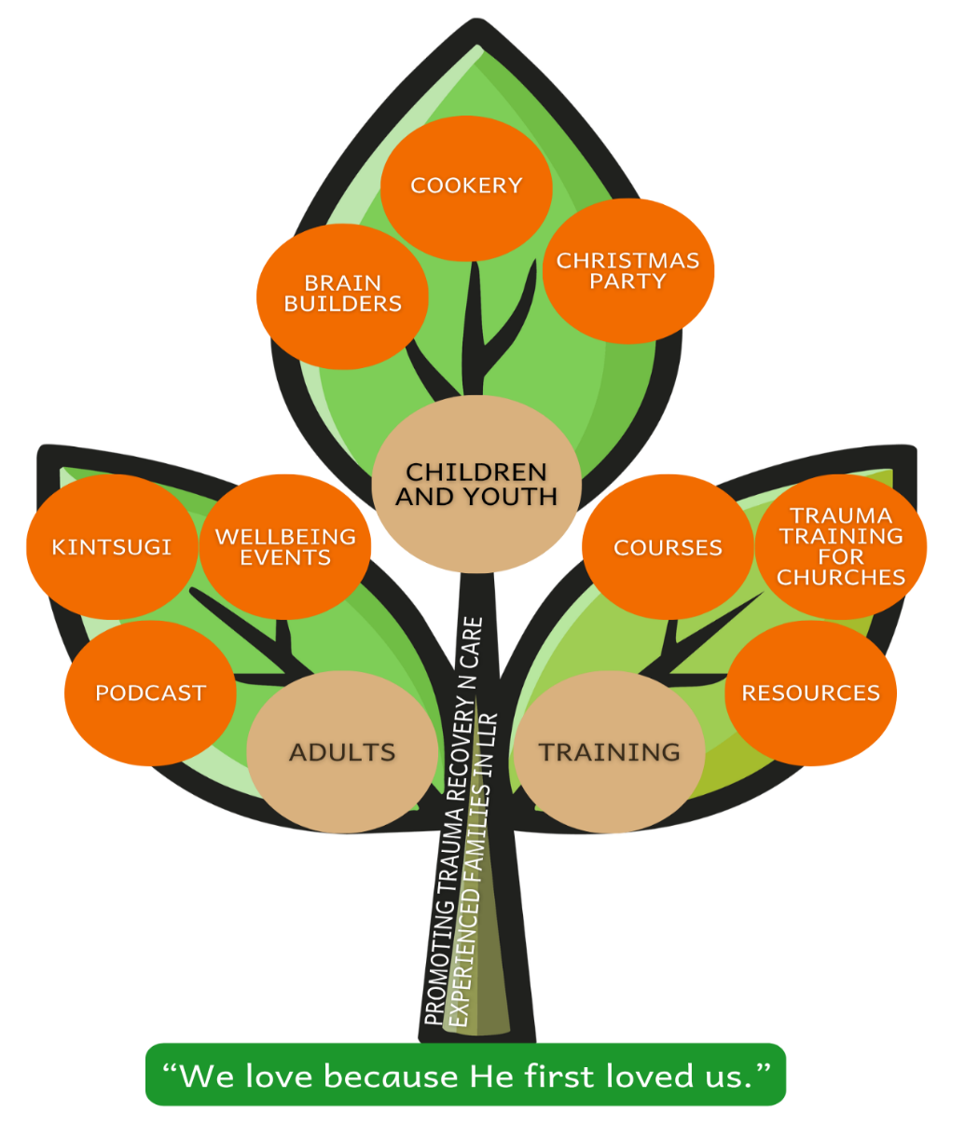

Children and Youth
Our current offer to children includes our Brain Builders project. CookStart and parties / celebrations.

- Brain Builders
Our Brain Builders project uses Lego Serious Play (LSP), a facilitated methodology that encourages participants to express ideas and concepts using Lego bricks rather than relying solely on verbal communication. This can lead to more effective communication. When we build, we engage the part of the brain that generates sensory images in our minds. This helps us to work out our ideas and develop deeper understanding. It helps with problem solving, forming narrative and reflection.

In 2025, two Raft volunteers were trained on LSP and they are now working on delivering Brain Builders sessions to care-experienced children, with the aim of running these sessions in a variety of settings (schools, after school clubs, churches, residential children’s homes etc). A further aim is to develop a set of resources and a toolkit explaining our approach, which can then be used to train other practitioners.

- Cook Start
Cook Start supports care-experienced young people aged 14 to 18 to develop the practical skills and confidence needed to prepare cost-effective, nutritious, and enjoyable meals. Cooking independently is a fundamental life skill that contributes to long-term wellbeing, resilience, and self-sufficiency.

Parents and carers are encouraged to attend sessions alongside the young person, helping to strengthen attachment bonds and reinforce learning at home. Our aim is to expand Cook Start by offering additional sessions that build participants’ confidence, broaden their recipe portfolio, and equip them with skills they can carry forward into adulthood.

- Parties
We offer a range of events throughout the year, including our annual Christmas Party and Summer Pool Party. These events provide valuable opportunities for care-experienced young people to spend quality time together, build friendships, strengthen connections, and have fun in a supportive environment. Our aim is to continue offering these much-loved events, helping to reduce isolation and promote a sense of community and belonging.

Adults

Our current provision for adults includes Kintsugi courses, wellbeing events and a regular podcast.

- Kintsugi
Kintsugi Hope is a mental health and wellbeing charity that provides courses for adults and youth on various topics such as depression, anxiety, anger, shame, healthy relations and resilience. We offer these courses to foster carers and adopters, and we hope to offer them to teenage children over time.

- Well-being events
We run regular craft and wellbeing sessions for parents and carers. These tend to include a craft activity, hand massages and time to chat over refreshments.

- Podcasts
Faith That Cares is a podcast, currently available on Spotify, that brings together conversations on fostering, adoption and the Christian faith. It started in summer of 2024 and releases episodes approximately every month. Episodes are recorded on Zoom and edited with Descript (the basis platform is available for free).

Key strategic aims for Faith That Cares:
- Promote podcast to a wider audience
- Add Faith That Cares to more hosting platforms
- Look at ways of involving the care experienced community
- Expand the Faith That Cares concept into resources, events and training.

Training and Development
We currently offer our beneficiaries a range of courses and resources, including trauma training and interactive videos.

- Courses
We deliver a range of training courses for adults looking after care-experienced children and organisations, such as churches, ideally at low or no cost, with a self-care element included so that we can reduce the risk of secondary trauma / re-traumatisation. Topics could include: child on parent violence, youth mental health, NVR, neuro-diversity, compassion fatigue etc. The aim is to equip parents, carers and others in their care-giving role to help promote family stability and increase skills and confidence.

Strategic aims:
- Continue to research training needs, perhaps using AI surveying tools
- Offer a variety of training in different formats and time slots
- Potentially establish a “learning community or hub” where expertise is shared.

- Trauma training for churches
We offer trauma training sessions for churches to raise awareness of trauma informed practices and the needs of the care-experienced community.
- Our strategic aim for this year is to deliver more courses to churches and to identify a possible funding stream from these courses.
- A further aim would be to engage on a church engagement “tour” and use this as an opportunity to promote our training offer.

- Resources
We have developed a suite of six introductory training videos covering key topics including safeguarding, trauma-informed language, neuroscience, stress responses, and attachment. These resources are available to individuals and organisations seeking foundational knowledge or an accessible entry point into these areas of practice.

Our strategic intention is to make these training materials freely available while inviting voluntary donations to the Raft to support the continued development and delivery of our work.

Exploration of emerging ideas, research and opportunities
We recognise that the science around trauma, attachment and neurodiversity is constantly evolving, the local care-experienced community is often in flux with families changing as children move and develop, and that we as a charity need to be responding to updated research, emerging themes and needs.

As a small charity, we want to be responsive to new ideas and able to respond quickly where it is appropriate. We are open to hearing creative ways of supporting our community to heal from past trauma and we are open to new partnership opportunities, recognising the unique skills, influence and resources of those we work alongside.

We want to develop a culture within the Raft for our trustees and volunteers to feel able to question existing practice and suggest ways of improvement. We want to invest in our trustees and volunteers, increasing their own knowledge and skills, as well as being able to access appropriate care as we respond to the significant needs of our beneficiaries.

Our market

Beneficiaries
Our beneficiaries are:
- Care experienced children and young people in Leicestershire
- Families of care experienced people
- Other people involved in the lives of care experienced people, including social workers, residential care workers, support teams, schools, churches, community organisations, essentially the team around a child.

Stakeholders
Our stakeholders may include:
- Local authorities, particularly children’s services
- Other fostering and adoption agencies (non-profit and charitable)
- Universities, for example through research projects
- Churches and faith organisations
- Foster carers, kinship carers and adopters

Donors and supporters
As of June 2026, we have 5 regular givers and we regularly send grant applications.
We also receive financial support from One Church on a monthly basis.

We receive in-kind support from Hope Community Church, Knighton Free Church, One Church, Leicester City Council, Leicestershire County Council, Leicestershire Cares and Leicester City in the Community.

Strategic aims:
- Attract more regular givers, (individuals and churches)
- Write a fundraising strategy
- Seek out opportunities for grant applications (for both restricted and unrestricted funds)

SWOT analysis
The following is an analysis of our situation and context as of summer 2026.
Strengths  Flexible organisation, can respond quickly to new ideas  Good links with local authorities  Faith based  We have lived experience  Unique position in Leicester (being faith and care focused)  Building our reputation and trust worthiness | Weaknesses  Small volunteer team, with other responsibilities  Small budget  Not many social media followers  Reliance on LAFS for access to beneficiaries.  Lack some skills in our existing team  Reliance on other venues
Opportunities  Room for innovation and positioning ourselves in a unique place.  Can apply for grants  New partnerships  Potential for own building | Threats  Need clarity about position and relationship with LAFS.  Lose track and focus on core vision  Volunteers leave  Safeguarding / allegations

Our brand and messaging
In 2024 we worked with Graffio to develop a logo and branding that reflected our ethos of being family friendly and accessible, linked to the idea of a “raft” being a collective noun for a group of penguins.

The brand kit they developed for us has a colour palette and font, and is used on our website, social media and on all our materials and printing.

We are committed to using affirming, positive, and inclusive language that recognises the strengths, identities, and lived experiences of care-experienced children and their families. Our approach emphasises collaboration, empathy, and psychological safety, ensuring that every interaction promotes dignity, agency, and belonging. We prioritise strength-based language, trauma-informed communication, and terminology that reflects diverse family structures and trusted relationships. This intentional use of language supports our mission to create safe, supportive environments where children and families feel valued, respected, and empowered.

Operational plan

Milestones and timescale
Organisational aim | Activity/Outputs | Milestones
Create and deliver activity under our three strands of work | Brain Builders  CookStart  Christmas party  Kintsugi course  Wellbeing sessions  FTC podcast  Training offer | 4 Brain Builder sessions by Dec 2026  3 CookStart sessions in 2026-27 academic year  50 podcast followers by Dec 2026  Two first aid training courses to be delivered by spring 2027  5 churches receive trauma training by end of summer 2027
Expand our trustee board | Trustee recruitment campaign | 1, or ideally, 2 more trustees recruited by summer 2027.
Create an operational team (CEO, administrator, project leads) and seek funding for these roles | Job descriptions  Employment policies  Funding applications  Payroll function | Job descriptions to be created autumn 2026  Update / create all necessary policies autumn 2026  Research possible funding streams and send applications by Spring 2027
Develop partnerships with churches | Church engagement “tour”  Awareness raising video | Speaking engagements at 10 churches by summer 2027.
Grow our prayer network | Regular prayer updates on WhatsApp group  Prayer bulletins  Develop mailing list | 30 by end 2026  50 by end 2027
Build a sustainable donor base of regular givers | Regular appeals  One off campaigns e.g. 100 for 10  Fundraising strategy | 10 regular givers by end 2026  50 regular givers by end 2027
Attract more followers to our social media platforms | Regular posts  Build Instagram and LinkedIn following | 300 Facebook followers by end 2026
Create a vision for the Raft Centre | Vision boards  VR walk through model? | Create a concept in 2027/8

Partners
We currently partner with the following organisations:

Name of organisation | Nature of relationship
Hope Community Church | Use of premises, accountability, prayer support
Knighton Free Church | Prayer updates, occasional use of venue
One Church | Financial and prayer support. Offer of building.
Leicester City Council | Share details about our activities with in-house foster and adoptive families  Regular meet-ups with Head of Fostering
Leicestershire County Council | Share details about our activities with in-house foster and adoptive families  Occasional meet-ups with Head of Fostering and Adoption
Kinship | Share details of events with kinship carers through East Midlands branch of Kinship
Leicestershire Cares | Reciprocal sharing of events and activities that benefit care experienced families. Provision of selection boxes for our Christmas party. Invitations to events and networking opportunities. Links with the business sector.
Leicester City in the Community (the Community Trust of Leicester City Football Club) | Reciprocal sharing of events and activities that benefit care experienced families. Use of venue for Christmas party. Occasional provision of promotional gifts and giveaways.
Home for Good | Share details of events and campaigns
LAFS (Leicestershire Adopters and Foster carers Support) | LAFS is a community and secret Facebook group of local carers and parents, that exists for peer support and networking. They run events and socials throughout the year.  A raft volunteer is the current chair of LAFS.  We often post Raft events on the LAFS Facebook page.  There is potential for joint projects.

Funders

We currently receive funding from the following organisations:

Name of funder | Type of funding
One Church | Regular giving, unrestricted
Asda Community Foundation | Grant, restricted
Leicestershire and Rutland Community Foundation | Grant, restricted
Samworth | Grant, restricted
Quorn Baptist Church | One off giving, unrestricted
Rotary Club (De Montfort branch) | One off giving, unrestricted

Premises and equipment

Premises
Hope Community Church is allowing us use of their building (The Kings Centre) for meetings and activities. We have use of office space one day a week and a storage cupboard for our resources. This is currently being provided for free; however, this arrangement will be subject to review as The Raft establishes itself.

Equipment
We currently own a wide selection of Lego, LSP kits, items for the care packages (including books) and Raft promotional materials.

Insurance
We have insurance with Zurich Plc, that covers the following:
- £5m Public Liability (includes cover for volunteers)
- Personal Accident
- £10m Employers Liability
- £25,000 Contents cover
- £100,000 Trustee Indemnity cover
- Cover for money on premises or in transit

Policies
We have the following policies in place:
- Safeguarding
- Equalities
- Data protection
- Conflicts of interest
- Trustee and volunteer recruitment
- Code of Conduct
- Financial Procedures Manual
- Health and safety (draft)
- Social media (draft)

People, management and governance

Our team
We currently have a team of 7 volunteers, consisting of four trustees and three team members.

Our board
We currently have three elected trustees, who serve a term of three years.

Name | Trustee role | Date elected | Contact for ...
Debbie Hill | Chair of Trustees | 12/2/25 | Chairing board meetings  Overseeing day to day delivery of The Raft.
Chris Plummer | Treasurer and Secretary | 17/06/26 | All finance enquiries  Agenda submissions and reports  Overseeing day to day delivery of The Raft.
Paul Cromwell | Safeguarding Lead | 17/0/26 | First point of contact for any safeguarding issue, question or concern. Overseeing day to day delivery of The Raft.
Carys Radford | General trustee | 1/1/25 | Overseeing day to day delivery of The Raft.

Proposed management structure

In time, we propose appointing a CEO to have overall responsibility for delivery of The Raft, with direct accountability to the Board of Trustees. The CEO will oversee a number of project leads, as well as a fundraiser, administrator, prayer lead and publicity officer.

The aim is to start initially with a CEO, administrator and project lead, on a part-time basis, and to build from there.

